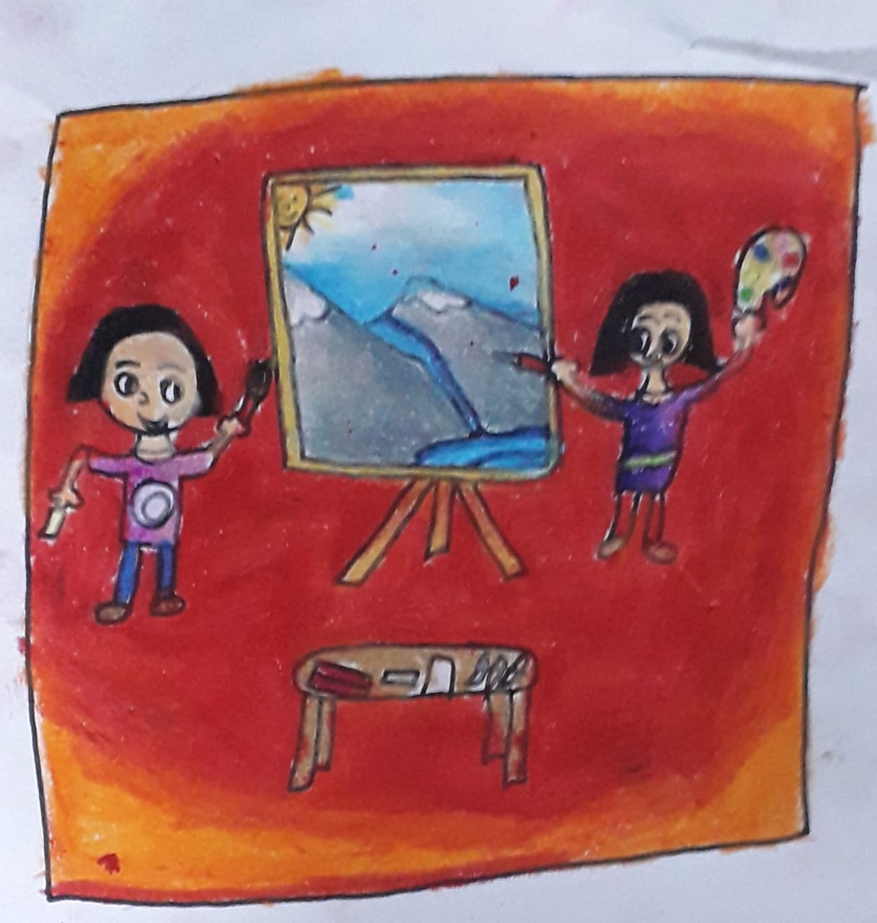
Hobbies during Quarantine
Pandemic Protection:
“Oh! When will we go out Dad and Mom? when will I go to school and see my friends and Thea”, willed an annoyed Lily.” I don’t know My Dear Lily “said Mom.” But We can do one thing!” said Dad.” What’s that Dad?” asked an excited Lily. “We can spread awareness about COVID 19” said Dad.” We can?!” asked a surprised Lily.” Yes, Lily we can, but I need your Help”, said Dad. “What help do you need Dad? I can do it” said Lily.” You are Attending Online Classes at school right! can you please call your friends and ask them to come to a webinar, where I will talk about the awareness of COVID 19” asked Dad.
“Yeah! Dad I will “said Lily. Later that evening Lily called Thea, her friends and her relatives to come, to a webinar about the awareness of Corona virus.
Awareness Association:
The next Day Lily’s Father was dressed as To-A -Tee for the webinar hosted by Lily .”This is the unmute Button and this is the mute and this is present Screen option “ explained Lily .”So Should I click the present screen option to present my Slides?” asked dad .”Of Course “ said Lily . Meanwhile Thea was teaching her parents and Grandparents about the Options in the webinar.
Spectacular Speech:
“Good Morning Ladies and Gentlemen “started Dad. “I’m going to tell you the awareness of the Pandemic COVID 19”.” So, who would like to volunteer to tell everyone the basic safety measures?”. questioned Dad. “I Will” said Uncle Ted.” Go Ahead Brother”. said Dad.” The Basic things we have to follow is wear a mask, sanitize your hands ,maintain social distancing ,stay at home and say Namaste instead of shaking Hands.” said Uncle .”That’s right ! now, let me present my screen to explain it clearly” said Dad.
Deep Discussion:
With a little help from Lily, dad was able to present his screen.” So, wearing a mask helps you to keep your face covered from infection “, continued Dad.” Now Thea! Could you please tell us Where and all we should wear a mask”? asked Dad. “Yes uncle, we should wear a mask, when we go out, since it ensures your sense organs are not colliding with the virus!” said Thea. Absolutely! now Lily, can you please, tell why we should use a Sanitizer?” asked dad. “Yes Dad, we should use sanitizer for making our hands clean and virus free, but we should be careful, not to bring it to a flame, because its inflammable.” said Lily.
“Thanks Lily, Now Aunt Sally, could you please tell the audience, why we should stay at home?” questioned Dad. “Yes Brown ,we stay at home ,so we can be away from infected people, we should also be aware not to go to public places and crowds .” said aunt Sally .”Thanks Sally ,now Saina ,please explain to the audience why we should say namaste ?“ asked Dad. “Yes Brown, when we shake our hands with others, people’s infections will come to us as well, so it’s better to say namaste “, said Mom.” Thanks, Saina, now our 2 Chief guests, our Grandparents will talk to us.” said Dad.
“Welcome Everyone ,It’s a pleasure , to see you all .I have an advice, don’t stay in A.C with others .This pandemic will get over soon” said Grandma Minty .”Till then do some hobbies and follow these rules” said Grandpa, Bob. “Thanks Everyone for attending this webinar, so patiently. Next Stop, Free from Corona” said Dad and ended the Webinar.
Next Stop, Free From COVID:
“Mom, I have an Idea!” said Lily. “What is it Lily?” asked Mom. “I could draw the safety measures of COVID 19 and stick it in public areas”, said Lily.” We could form a team with Thea’s Family and wear masks and gloves and stick it “said Dad. “And the Name of our Team will be COVID WARRIORS!” said Lily.
Soon the following day, the COVID WARRIOR’s took the safety measures like wearing masks, gloves and used sanitizers etc and then Thea asked, “So where shall we start?”. “Here are our COVID protection Suits with our Team name engraved on it and we could start by the public park, after wearing this”, said Aunt. Soon they went to Lots of Public places like Hotels, Shops, Parks, Rest rooms etc and stuck the Posters and they also gave the pamphlets to the grocery stores, to give it to people who visit the stores.
Next the COVID Warriors walked in the streets and visited public places, shouting slogans about the safety measures of COVID. They also gave food packets to the starving people in the streets who had lost their jobs during the lockdown.
They also appreciated the Doctors, Nurses, Healthcare workers and Polices officers who were sincere and not hesitant to perform their duties, amidst so much turmoil due to the pandemic.

Lockdown Hobbies:
“Lily, Thea, I found an online drawing class, would you two, like to join the class, during this Quarantine, it would keep you busy. “asked Aunt.” Yes, Yes and a double Yes! “chorused Lily and Thea.” Ok then, be ready at 4-5 Pm daily “aunt said. That day at 4 PM both joined the drawing class, and their drawing teacher Ms. Ray was a really a cordial teacher.” Hi, Lily and Thea, we welcome you both to our online drawing class.” Said Ms. Ray.” Good Evening Ma’am “said Lily and Thea. “Your First drawing lesson 0will be drawing horizontal, vertical, zig zag and curvy lines”. said Ms Ray. Later She then gave them some fun homework to practise at home.
Summer-camp Fun:
“We also found you a Summer Camp daily ,12 Noon-2 PM” said Dad. “There will be origamis, songs, dance, debates and lots more fun games”. “We want to join please! “exclaimed both. They enjoyed their first day at summer camp merrily.
Enjoy at Home:
Thea made different indoor games like bowling, Pin-the-tail etc and Lily also made different contests and games. They also made clay moulds and cotton cloths by stitching.” Contests of yours is nice. So, we can hold online contests in different live meetings “, suggested Mom. “Great Idea Mom!”. said Lily. They organized various online contests and gave prizes for the winners. They also wished that their quarantine time would be over in a month or two.
“Good hopes always come true soon”
By
Sharadha T
3rd Standard

